Ans. To The Question No. 02

Android is a open-source platform designed primarily for mobile devices, developed by Google. But nowadays it is also used in other devices such as tablets, smartwatches and televisions. Android architecture is a software stack of components to support mobile device needs. Android software stack contains a Linux Kernel, collection of c/c++ libraries which are exposed through an application framework services, runtime, and application.

Ans. To The Question No. 03

An activity provides the window in which the app draws its UI.

Ans. To The Question No. 04

There are multiple ways to handle click events of a Button such as:

1. OnClickListner:

Example:

Button button = findViewById(R.id.button);

button.setOnClickListener(new View.OnClickListener() {

@Override

public void onClick(View v) {

}

});

1. XML on Click Attribute:

Example:

<Button

android:id="@+id/button"

android:layout_width="wrap_content"

android:layout_height="wrap_content"

android:text="Click Me!"

android:onClick="onButtonClick" />

Ans. To The Question No. 05

The activity lifecycle in Android refers to the series of events that occur as an activity transitions between different states, such as being created, started, resumed, paused, stopped, or destroyed. Understanding the activity lifecycle is crucial for managing the state and behavior of an activity throughout its existence.

Ans. To The Question No. 06

An Android application framework is a software toolkit that enables app developers to piece together a finished product that meets the requirements of its proprietor. It serves as the foundation for developing Android applications and provides developers with a set of tools, libraries and resources to build robust and feature-rich mobile applications.

Ans. To The Question No. 07

LinearLayout:

* Arranges child views either horizontally or vertically.
* Supports weighted distribution for flexible layouts.
* Simple hierarchy, efficient performance.
* Suitable for simple linear arrangements.

RelativeLayout:

* Positions views relative to each other or the parent.
* Offers flexible alignment options.
* Simplifies nesting, reduces view hierarchy.
* Provides more flexibility for complex layouts.

In summary, LinearLayout is ideal for simple linear layouts, while RelativeLayout offers more flexibility and reduced nesting for complex layouts. Choose based on specific layout requirements and design considerations.

Ans. To The Question No. 08

* Configures the app with important details like package name and version.
* Declares components like activities, services, and broadcast receivers.
* Specifies required permissions for accessing device resources.
* Defines intent filters for inter-component communication.
* Ensures backward compatibility with SDK versions.
* Manages the application's lifecycle and behavior.
* Allows inclusion of custom metadata for additional information.

Ans. To The Question No. 09

The Android SDK (Software Development Kit) is a collection of tools, libraries, and resources provided by Google that developers use to create applications for the Android platform. It includes various components that assist in building, testing, and debugging Android applications. Some of the components are of Android SDK are:

* Android Development Tools (ADT):
* Android Studio
* Android SDK Tools
* Android Platform Tools
* Android Libraries and APIs
* Emulator
* Documentation and Samples

Ans. To The Question No. 10

Nesting layouts in Android Studio refers to the practice of placing one layout inside another to achieve more complex and intricate UI designs. By combining different types of layout managers, developers can create versatile and dynamic user interfaces.

Example:

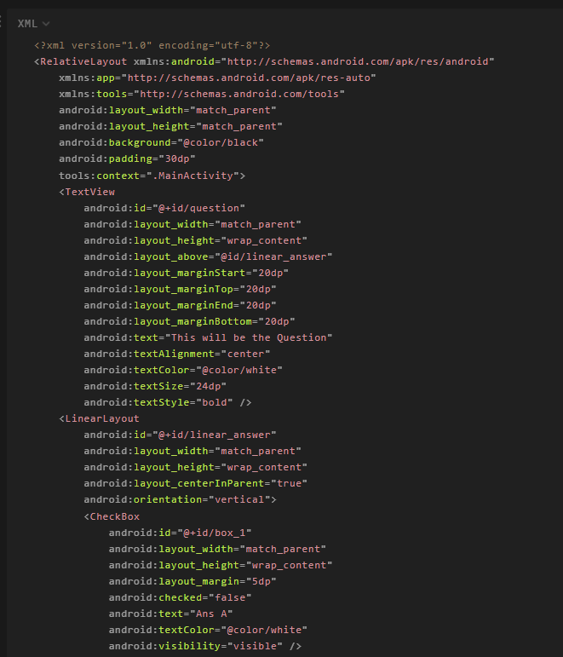

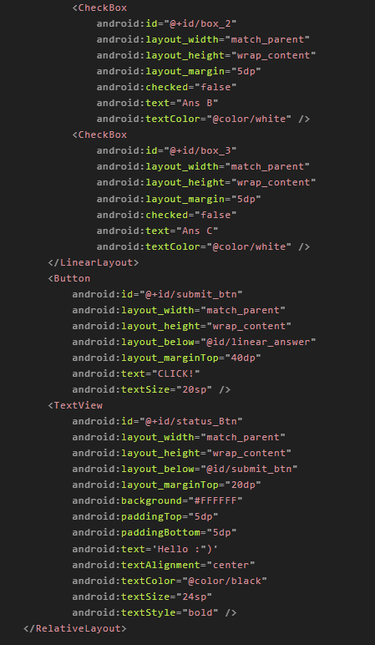

Output:

